Bugs Screenshots
Bug-1: Skip button overlaps the info-icon details during organization setup
Step-1: Login to ablespace and click on Account.
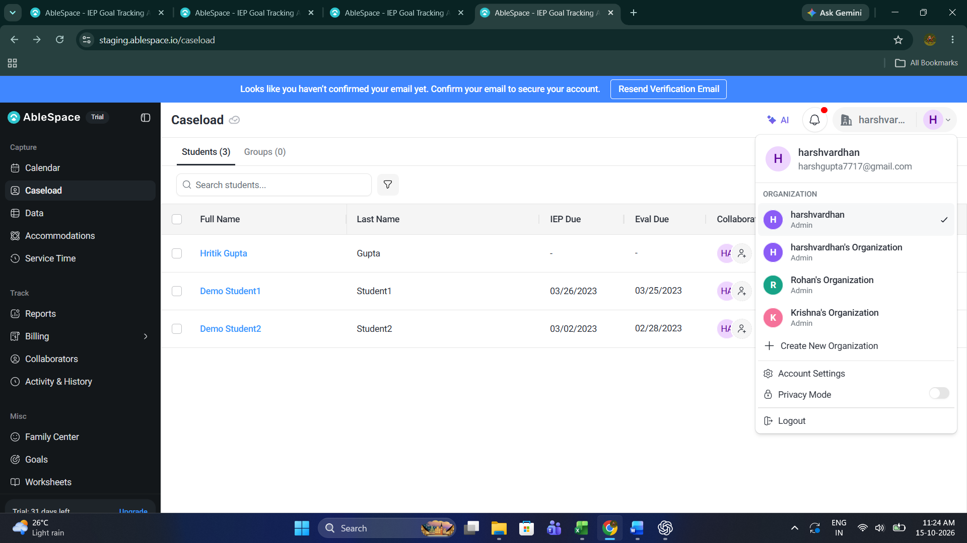

Step-2: Select Create New Organization button.

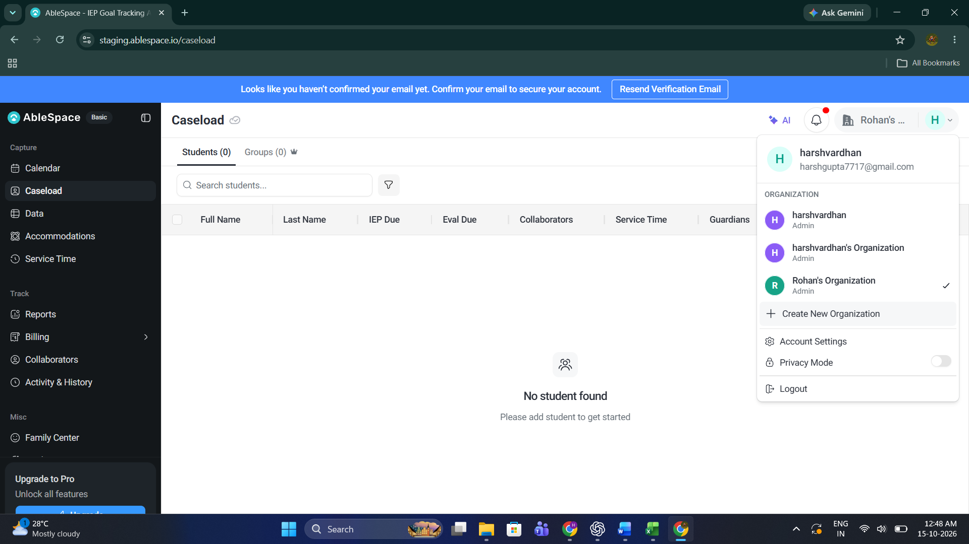
Step-3: Add the organization name and user will see this screen.

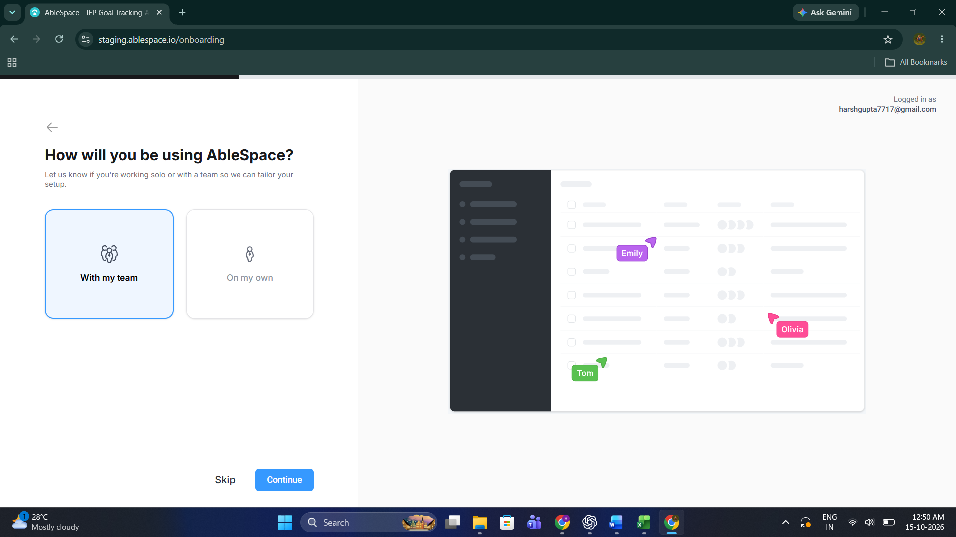

Step-4: Select any option and click on Continue, Skip button overlaps the info-icon details during organization setup

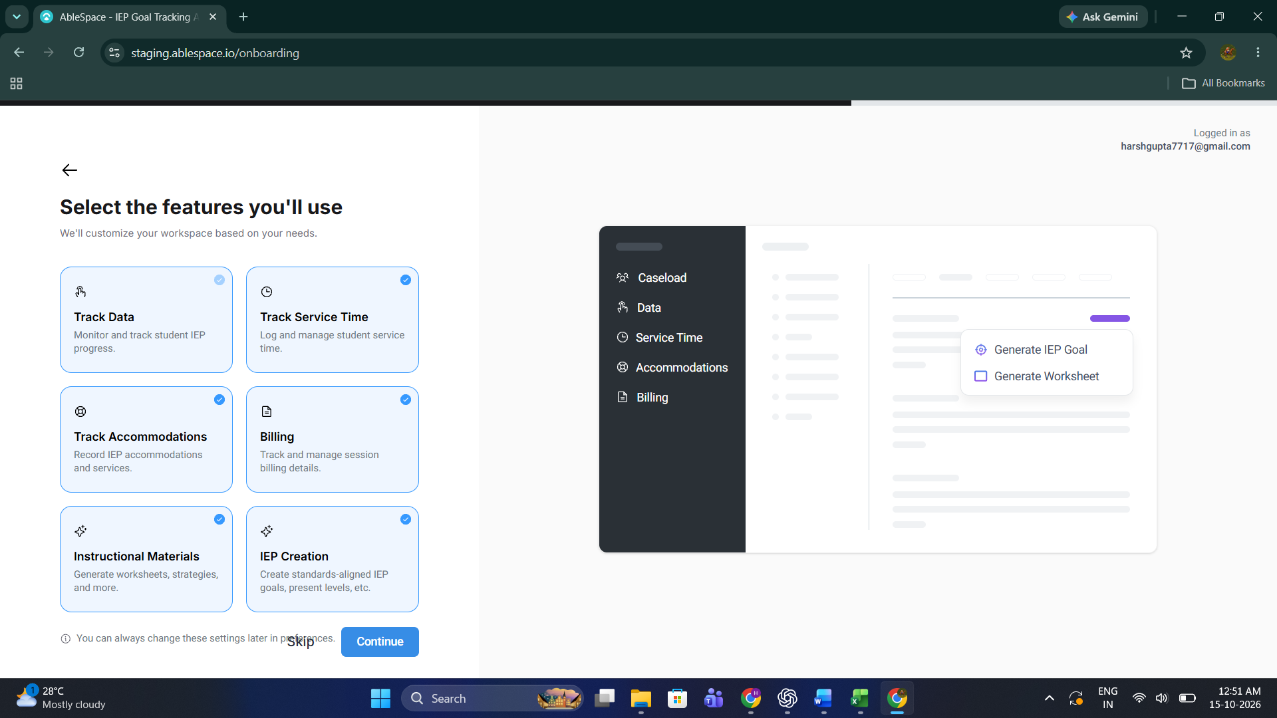

Bug -2 : Account profile shows zero sessions while billing export contains three rows
Step-1: 1. Sign in to staging.

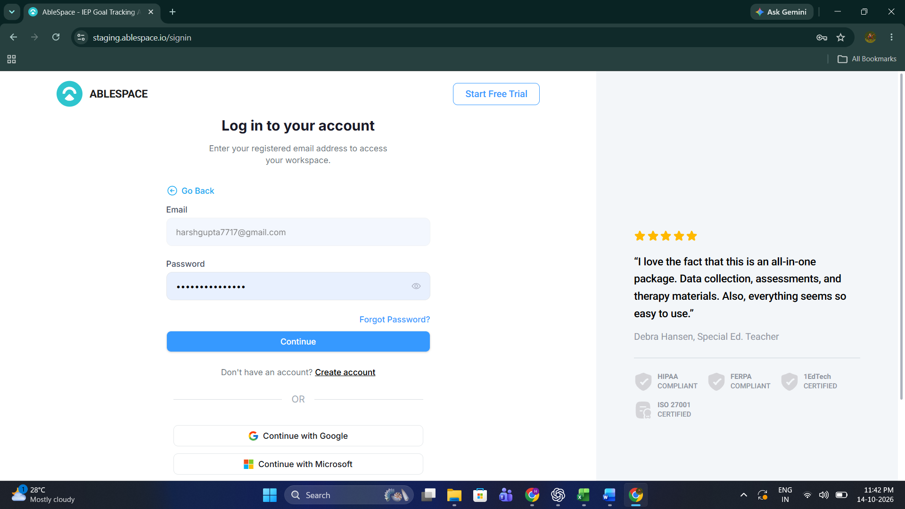

Step-2: Open Billing → Bulk Export.
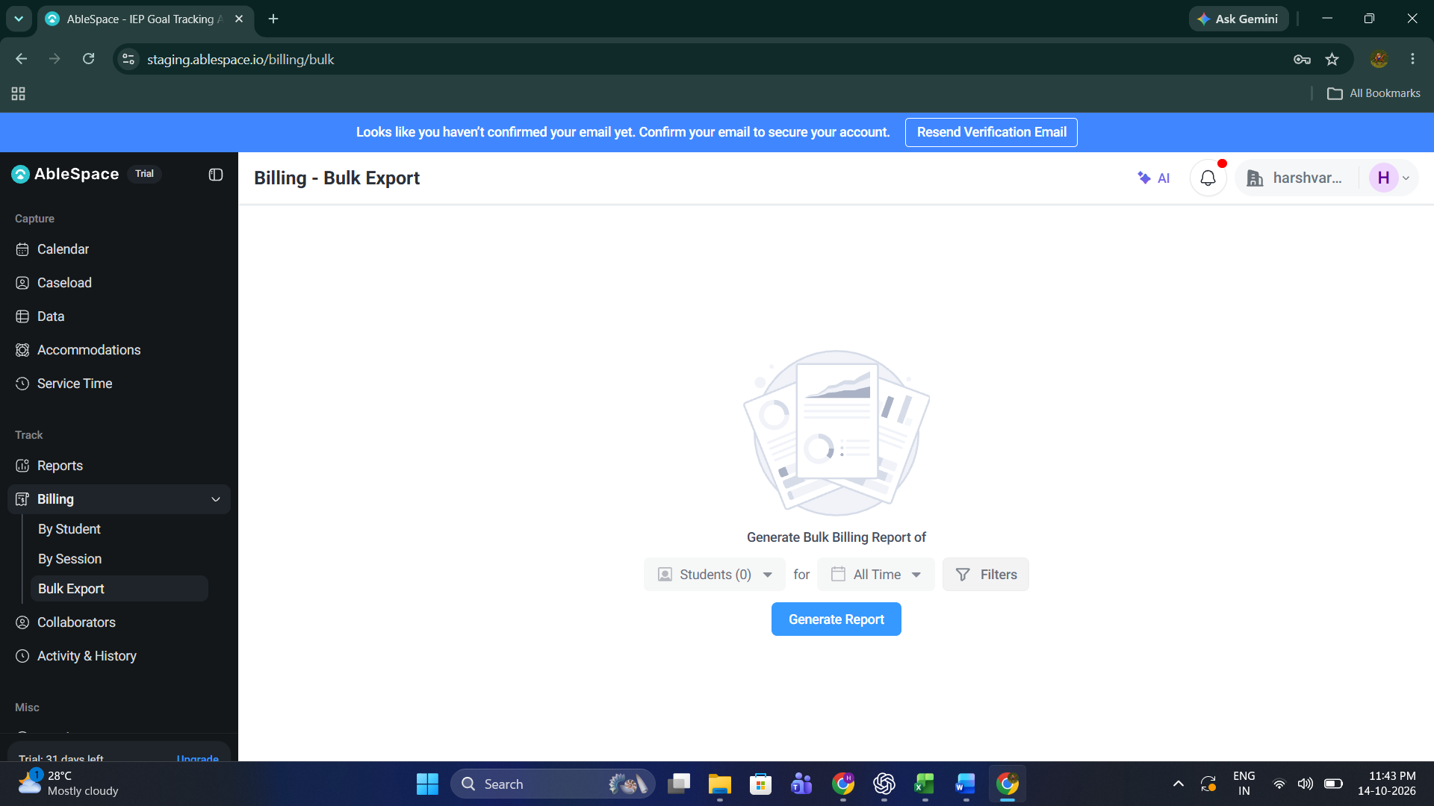

3. Select select any student and generate the report.
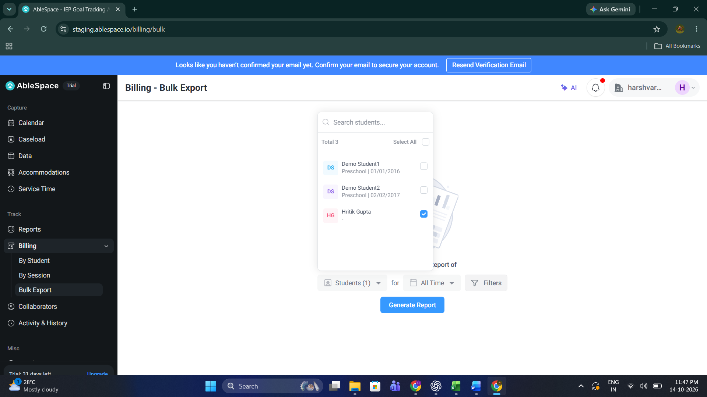

4. Note the 3 rows.

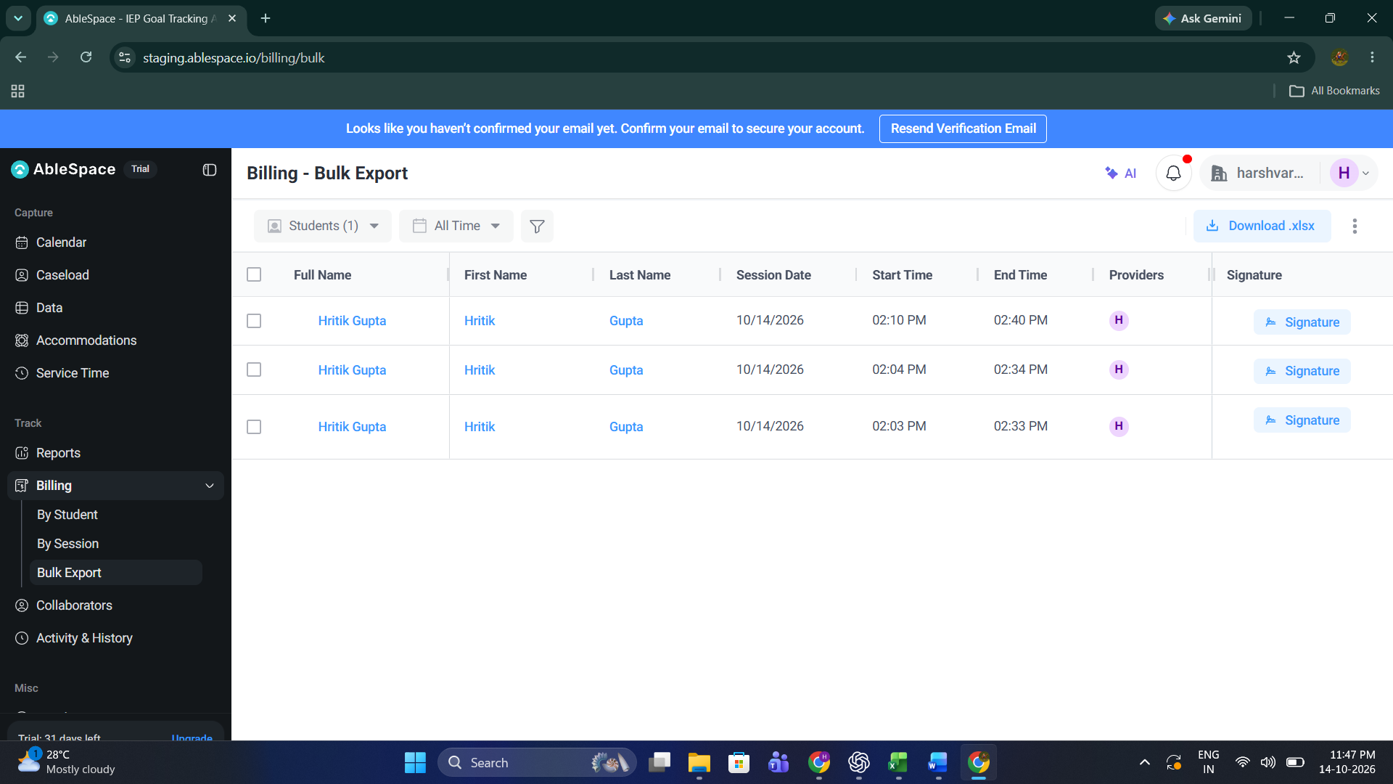

5. Open Account Settings → My Account and check Sessions.

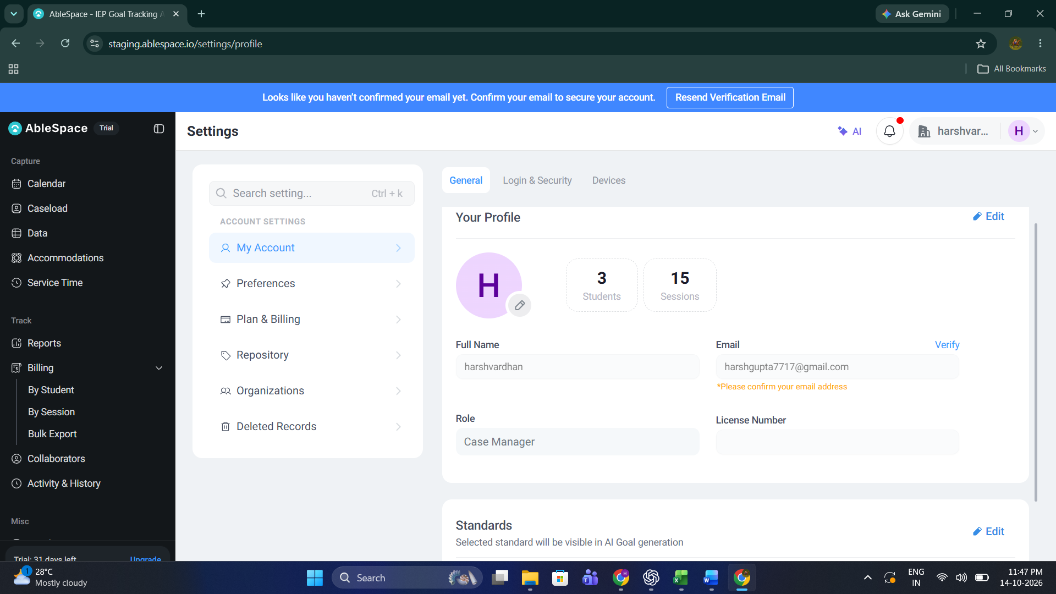

Bug–3: Apps search shows a blank catalogue when there are no matches
1. Open Apps.
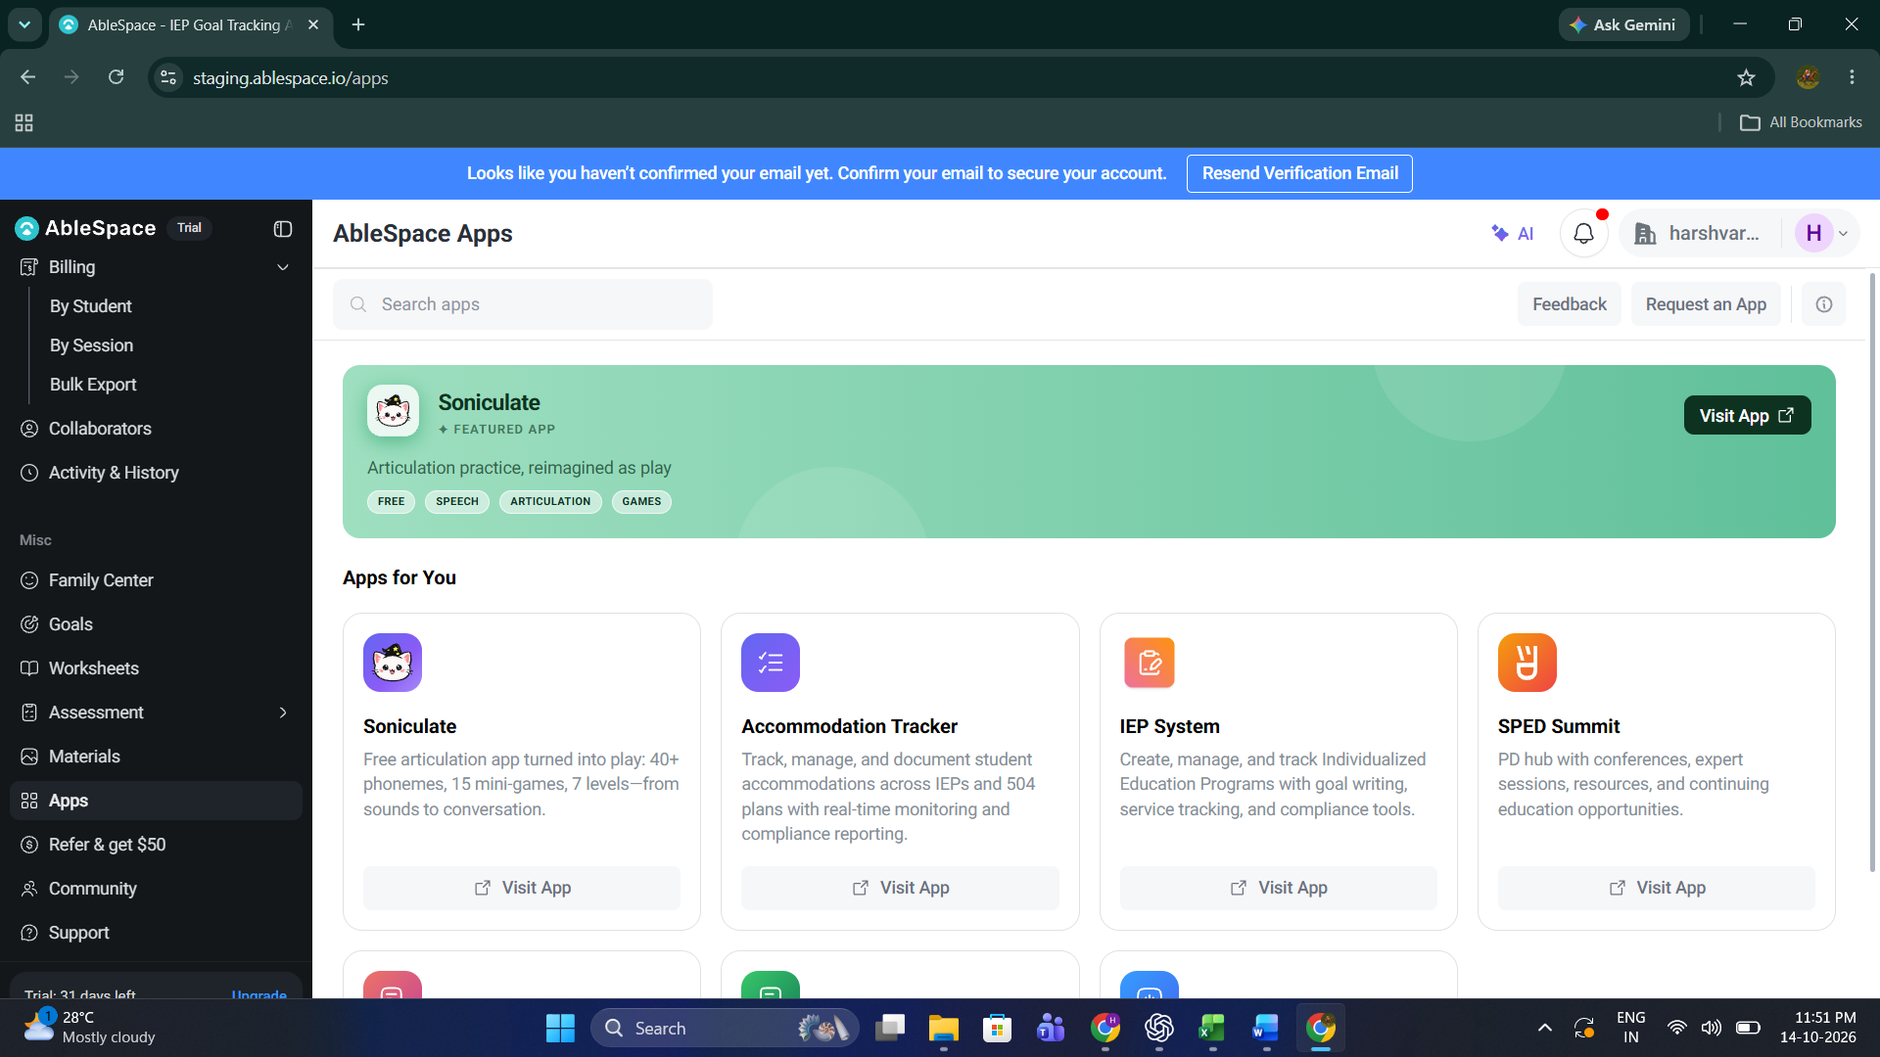

2. Search for gzzqafak.

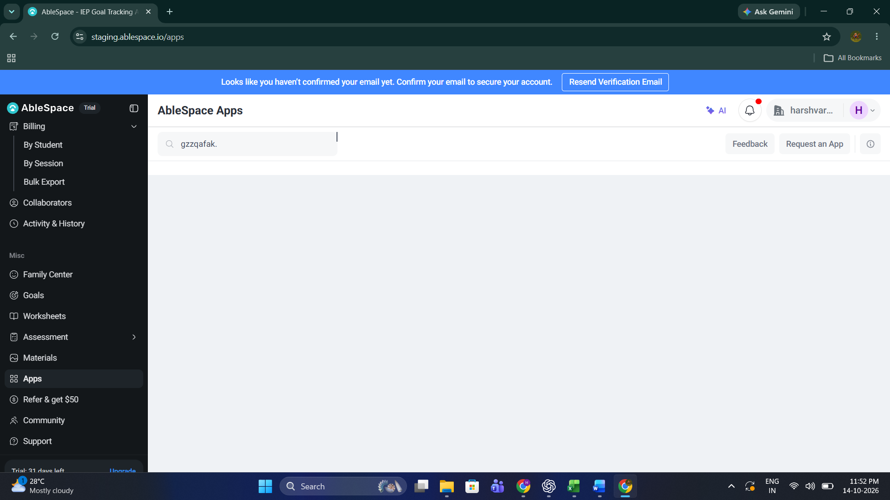
3. Review the results area.
When a user searches for an app that does not exist, the app cards option disappear and the results area appears blank.
The page does not display a (No apps found) message.

